3rd July 2023

Dear
I am writing to you to provide support for a member of your team to attend the next British Transplant Society Annual Congress.

This Congress provides a valuable opportunity to learn more about all aspects of donation and transplantation. This includes but is not limited to the following; living and deceased donation for solid organ transplantation, all organs commonly transplanted in the UK, Donor to recipient issues, machine perfusion, clinical trials and novel therapies including xenotransplantation.

In comparison to other donation and transplant related meetings the total cost is competitive. The Congress provides an ideal opportunity for Nurses and Allied Health Professionals to network, share ideas, develop research projects and explore gaining experience from one another.

The wealth of experience that is accessible at this Congress means that all attendees leave feeling inspired and enthused about the exciting developments and achievements within the arena of transplantation. By supporting the attendance of your team member you will be positively demonstrating your commitment to their continuing professional development. At this congress your team member can accrue up to 20 hours of CPD to count towards their revalidation. They are also eligible to apply for bursaries and details for the same are on the website.

As President of the British Transplantation Society I am keen to encourage new members to join the BTS for the professional development, networking and shared practice opportunities this can provide. However, without the support of a line manager undertaking this venture can be problematic, both logistically and within the dynamics of the workplace. Therefore, this letter is intended to help the nurses and management to facilitate attendance.

Yours faithfully,

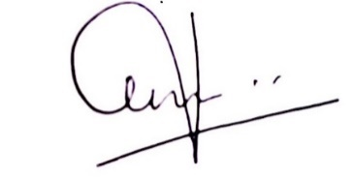
Krish Menon, President

